Progress Status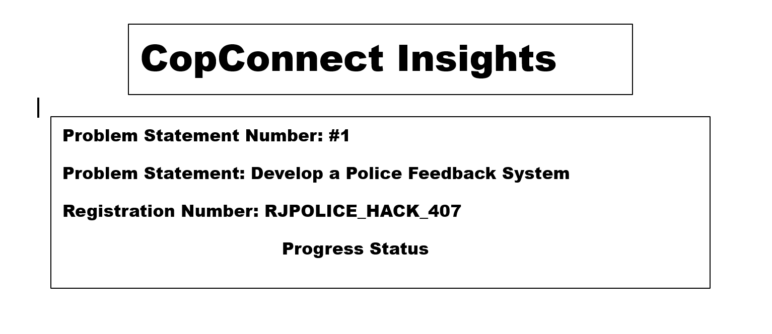1.Progess completed

* Portal
* Login and Sign up
* Admin Login
* Admin Dashboard
* Chat Bot
* Feedback And Compliant Registration Form

2.Future Plans

* Sms tool

1.WelcomePage

Progress Status

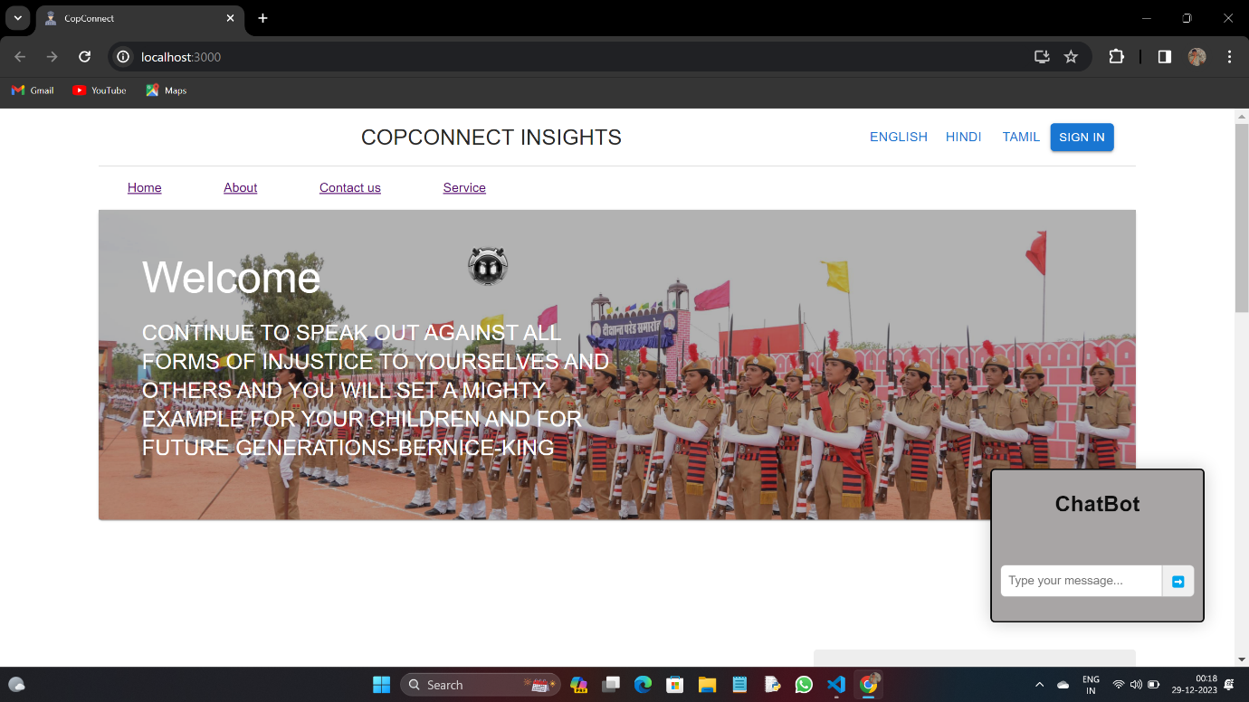

2.Sign In

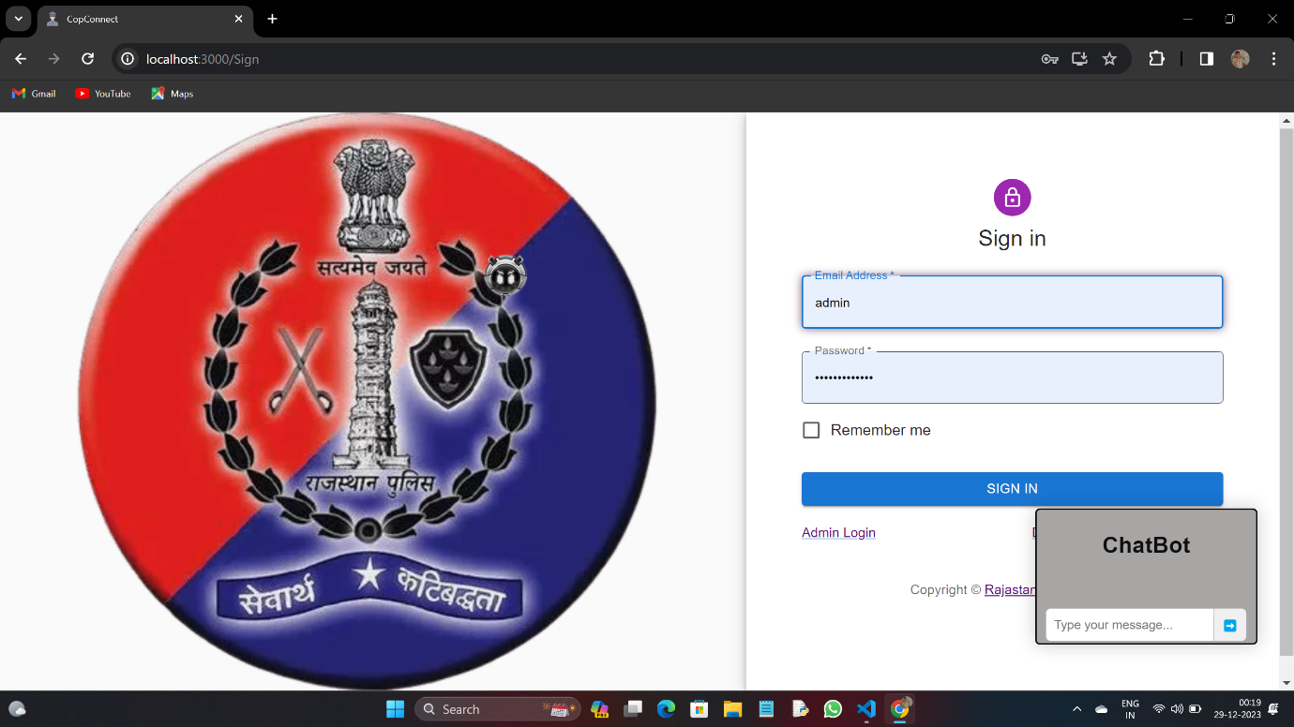

3.Officials Login

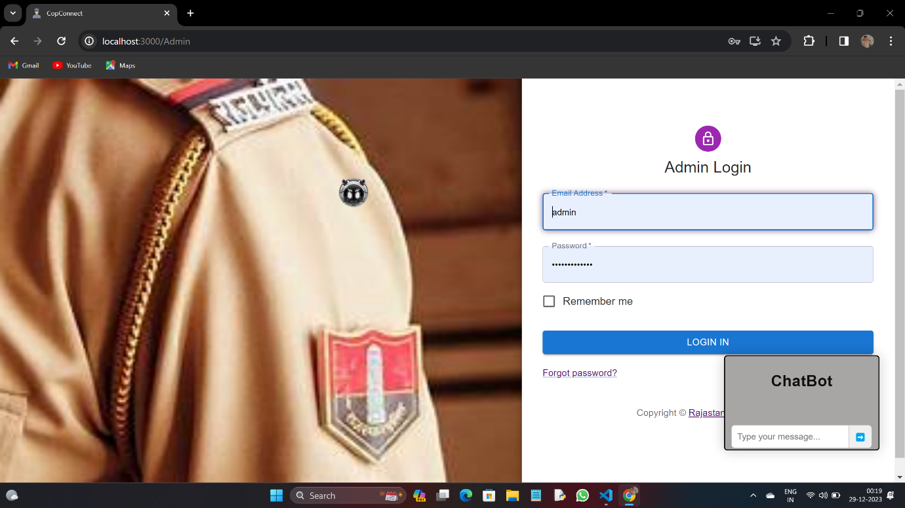

4.Admin DashBoard

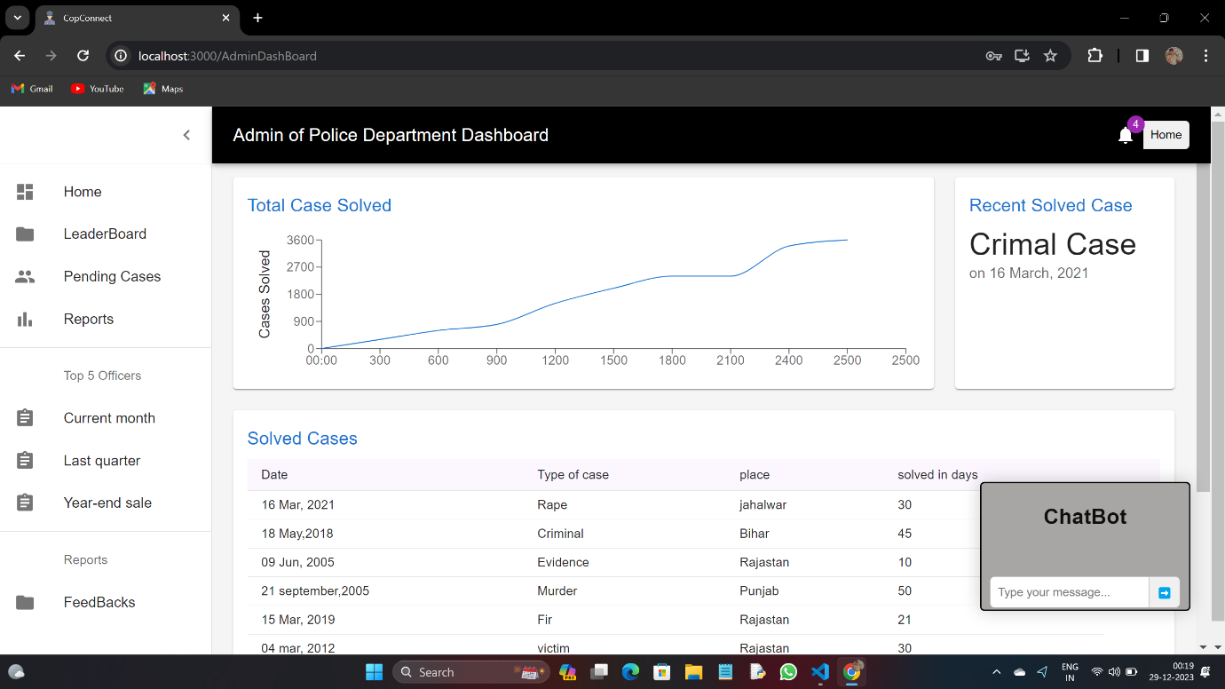

5.Home page

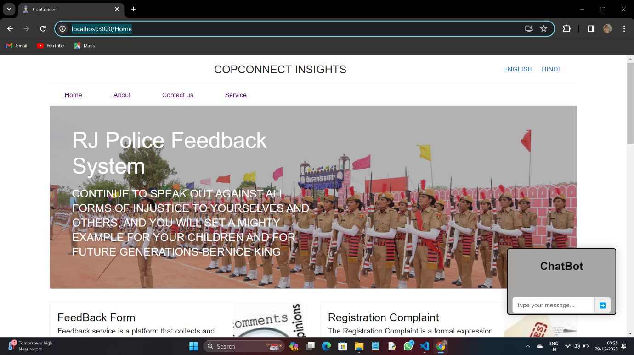

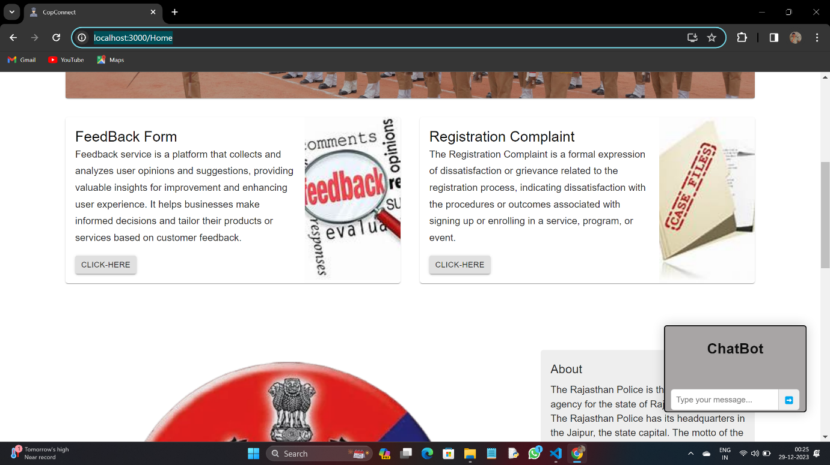

By click the Feedback block

->redirect to Feedback Form

->data Saved in Admin DashBoard

6.FeedBack System

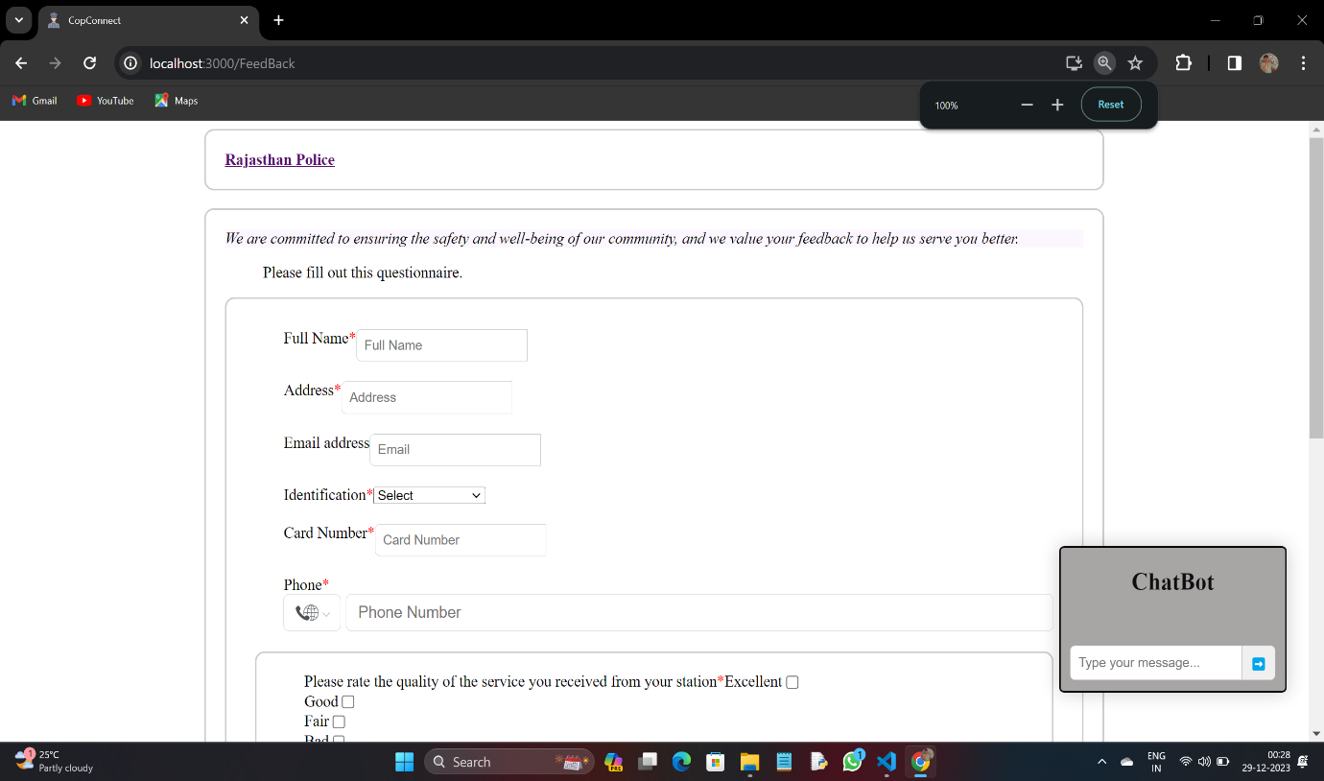

7.Responsive Chat Bot

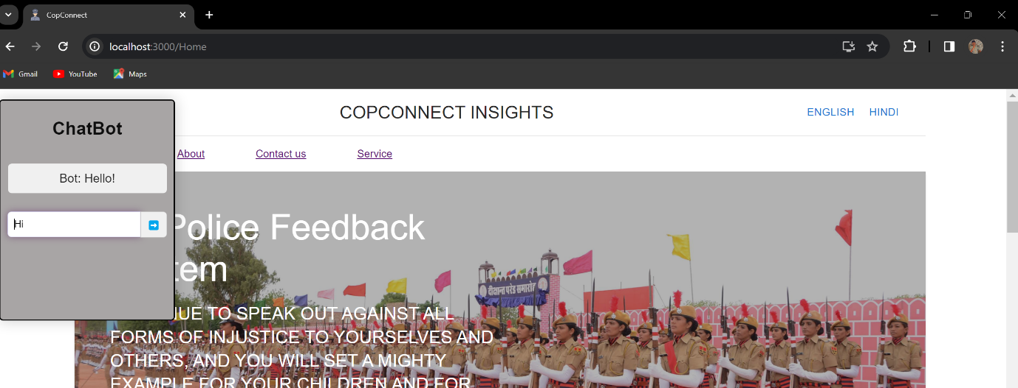

7.Give navigation for Feedback Form

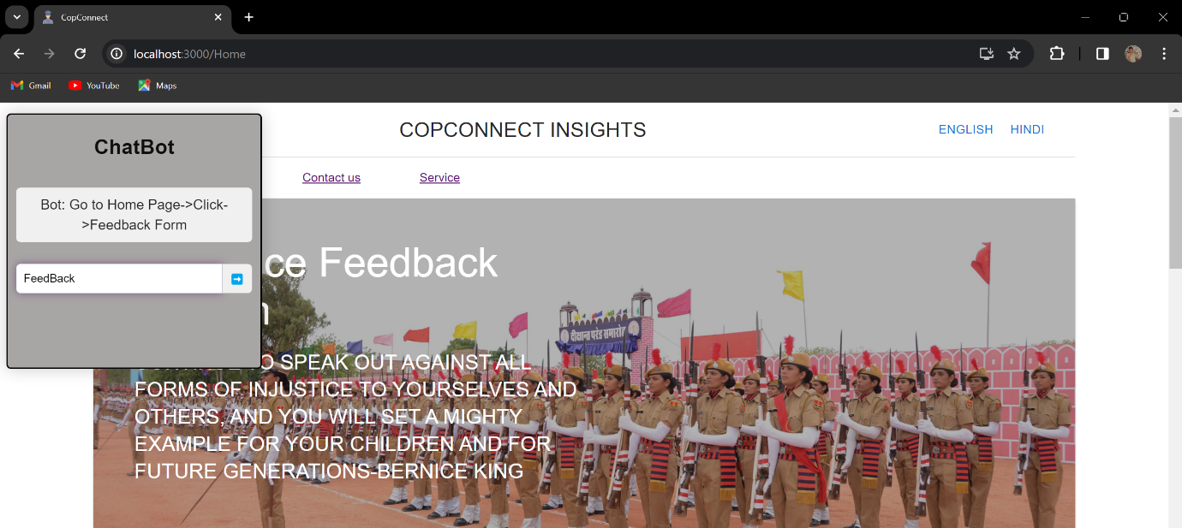

Same Procedure for Complaint Registration